Name _________________________________________________ Period _________________

Chapter 1 | Numerical Expressions and Factors
Date: | Lesson 1.1 Whole Number Operations
Essential Question | How do you know which operation to choose when solving a real life problem?
Review
Vocab Chart | Addition  Subtraction  Multiplication  Division
Vocabulary | Write each number in the division problem shown next to the correct term.  Divisor: ____________________ 26  Dividend: _________________ 34 884  Quotient: _________________
Practice | 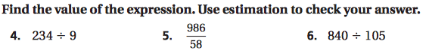
Practice | 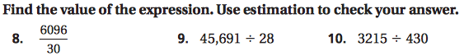
Geometry Connection | What is the perimeter and area of the shape below?  Perimeter: ____________________________  5 in.  Area: ________________________________  7 in.

Chapter 1 | Numerical Expressions and Factors
Date: | Lesson 1.2 Powers and Exponents
Essential Question | How can you use repeated factors in real-life situations?
Vocabulary | Word Definition Example  a product of repeated factors  repeated factor  the number of times the base is multiplied
Practice | 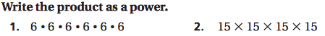
Practice
Practice | 7. John Deere makes its toy tractors identical to real tractors. The smallest tractor shown is 3 inches long. If each toy tractor is three times larger than the previous toy tractor, how long is the largest toy tractor? Write a power to represent the length of the largest toy tractor. Then find the length of the largest toy tractor.  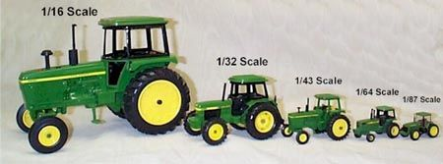
Vocabulary and Concept Check | 8. How are exponents and powers different?  9. Which one does not belong with the others? Explain.  a) 2⁴ = 2 x 2 x 2 x 2  b) 3 + 3 + 3 + 3 = 3(4)  c) 3² = 3 x 3  d) $5 ∙5 ∙5= 5^{3}$

Chapter 1 | Numerical Expressions and Factors
Date: | Lesson 1.3 Order of Operations
Essential Question | In what order do expressions need to be solved?
Vocabulary | Word Definition Example  expression that only contains numbers 3 x 5 + 6  find the value, or answer 3 x 5 + 6 15 + 6 = 21  1) parentheses 2) exponents 3) multiply or divide left to right 4) add or subtract left to right Please Excuse My Dear Aunt Sally PEMDAS
Symbols | 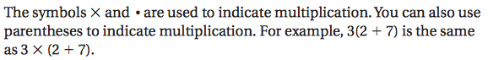
Practice
Practice | 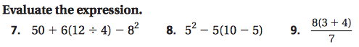

Chapter 1 | Numerical Expressions and Factors
Date: | Lesson 1.4 Prime Factorization
Essential Question | Without dividing, how can you tell when a number is divisible by another number?
Vocab | Factor pairs are 2 numbers that are multiplied together to get a product.  Example:
Practice | 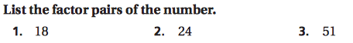  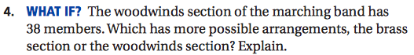
Vocabulary | Word Definition Example  a number that only has the factors 1 and itself 13 1 x 13 = 13  A number that has more factors than 1 and itself 15 1 x 15 and 3 x 5 = 15  A strategy to find the prime factorization of a number 18 2 x 9 3 x 3  Writing a composite number as a product of prime numbers 2 x 3 x 3 2 x 3²
Practice | Write the prime factorization for each number. Use a factor tree to help.  5) 20 6) 88 7) 90
Practice | Find the number represented by each prime factorization.  8) 2³ x 3² x 5 9) 2 x 3³

Chapter 1 | Numerical Expressions and Factors
Date: | Lesson 1.5 Greatest Common Factor
Essential Question | How can you find the greatest common factor of two numbers?
Vocabulary | Word Definition  factors that are shared by two or more numbers  the greatest, or biggest, of the common factors
Strategy 1 | Make a list of factor pairs.
Practice | Find the GCF of the numbers using lists of factors.  1) 8, 36 2) 18, 72
Strategy 2 | Use prime factorization by making a factor tree.
Practice | Find the GCF of the numbers using prime factorization.  3) 20, 45 4) 32, 90
Practice | 5) You are making identical flower arrangements to put on tables at a wedding. You have 84 red roses and 60 white roses. What is the greatest number of flower arrangements you can make?

Chapter 1 | Numerical Expressions and Factors
Date: | Lesson 1.6 Least Common Multiple
Essential Question | How can you find the least common multiple of two numbers?
Vocabulary | Word Definition  multiples that two numbers have in common  the least, or smallest, multiples that two numbers have
Strategy 1 | Make a list of multiples. Skip count to find the multiples.
Practice | Find the LCM of the numbers using lists of multiples.  1) 3, 8
 | 2) 9, 12
 | 3) 6, 10
Strategy 2 | Use prime factorization by making a factor tree.
Practice | Find the LCM of the numbers using prime factorizations.  4) 14, 18 5) 28, 36
Practice | 6) Trains on two different subway lines have just arrived at the station. Line A has trains that arrive every 12 minutes. Line B has trains that arrive every 15 minutes. In how many minutes will trains on Line A and Line B arrive at the station at the same time?

Chapter 1 | Numerical Expressions and Factors
Date: | Lesson 1.6 ext Adding and Subtracting Fractions
Essential Question | How can you add or subtract fractions?
Vocab

